Lab Exercise 2 – Object-Oriented Techniques.

1. Download the skeleton application from Blackboard.
2. Your goal for this lab exercise is to fill in the gaps in the Business Layer. **The only layer you’re can change is the Business Layer.** There is one more missing pieces each of the classes in the business layer using the following pieces of information.
   1. Entity Diagram

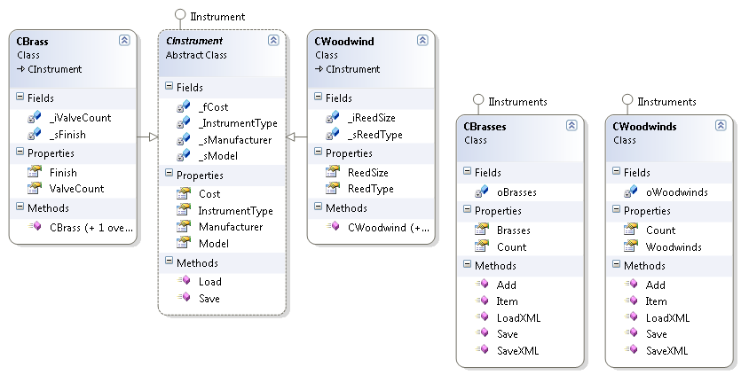

* 1. Error List in Visual Studio when trying to compile.
  2. Code you can inspect from the User Interface, Data Layer, and the Interface layer.
  3. All references are intact.
  4. You are not allowed to add any more files are any kind to the solution.
  5. You are not allowed to change and object relations such as inheritance or implementation.
  6. CBrass.ValveCount is a Read-Only property and should stay that way.

1. User interface
   1. Area for Brass instruments.
   2. Area for Woodwind instruments.
   3. For testing purposes:
      1. Fill – Adds two instruments to the Generic List
      2. Save – Saves the XML documents.
      3. Clear – Clears the datasource and objects.
      4. Load – Loads the XML documents.